Task 1
Вы просмотрите видео. Определите, какие из приведенных утверждений 1-10 соответствуют содержанию текста (True), какие не соответствуют (False) и о чем в тексте не сказано ( Not stated). Занесите букву выбранного вами ответа в таблицу с ответами.
- Two of three British people over the age of 15 read newspapers every day.
- In tabloids you will find serious information.
- In quality papers you will find more news, more serious articles and fewer pictures.
- People use different websites to read news on-line.
- The BBC is the broadcasting corporation, famous all over the world.
- On average British people watch almost 24 hours of TV a day.
- It is interesting that in Britain every family has a TV at home.
Утверждение: | 1 | 2 | 3 | 4 | 5 | 6 | 7
Соответствие видео:

Task 2
На основе просмотренного видеоролика о СМИ в Великобритании,
закончите фразы, выбрав один из вариантов ответа a, b или c
1) In tabloids papers in Britain you will find  a more entertaining articles  b fewer pictures and serious news  c stories about life and scientific reports  2) The most popular broadsheets contain  a humorous stories about different aspects of British life  b serious information and some pictures  c a lot of adverts, quizzes, celebrity news  3) A great amount of people in Britain  a are using various sites to get information  b don`t buy a newspaper but find news online  c surf the Internet every day  4) The BBC in Britain  a includes advertising during the programmes  b is a broadcasting commercial corporation  c consists of national and local radio stations and some terrestrial TV channels  5) ITV is the British  a independent, commercial TV channel  b well-known advertising TV channel  c TV channel, making films, shows and other entertaining programmes | 6) On average British people watch almost 24 hours of TV  a a day  b a week  c a fortnight  7) Most households have  a a TV and a washing machine  b more than two TV sets  c a TV and a video recorder
Номер задания: | 1 | 2 | 3 | 4 | 5 | 6 | 7
Ответ:
Task 3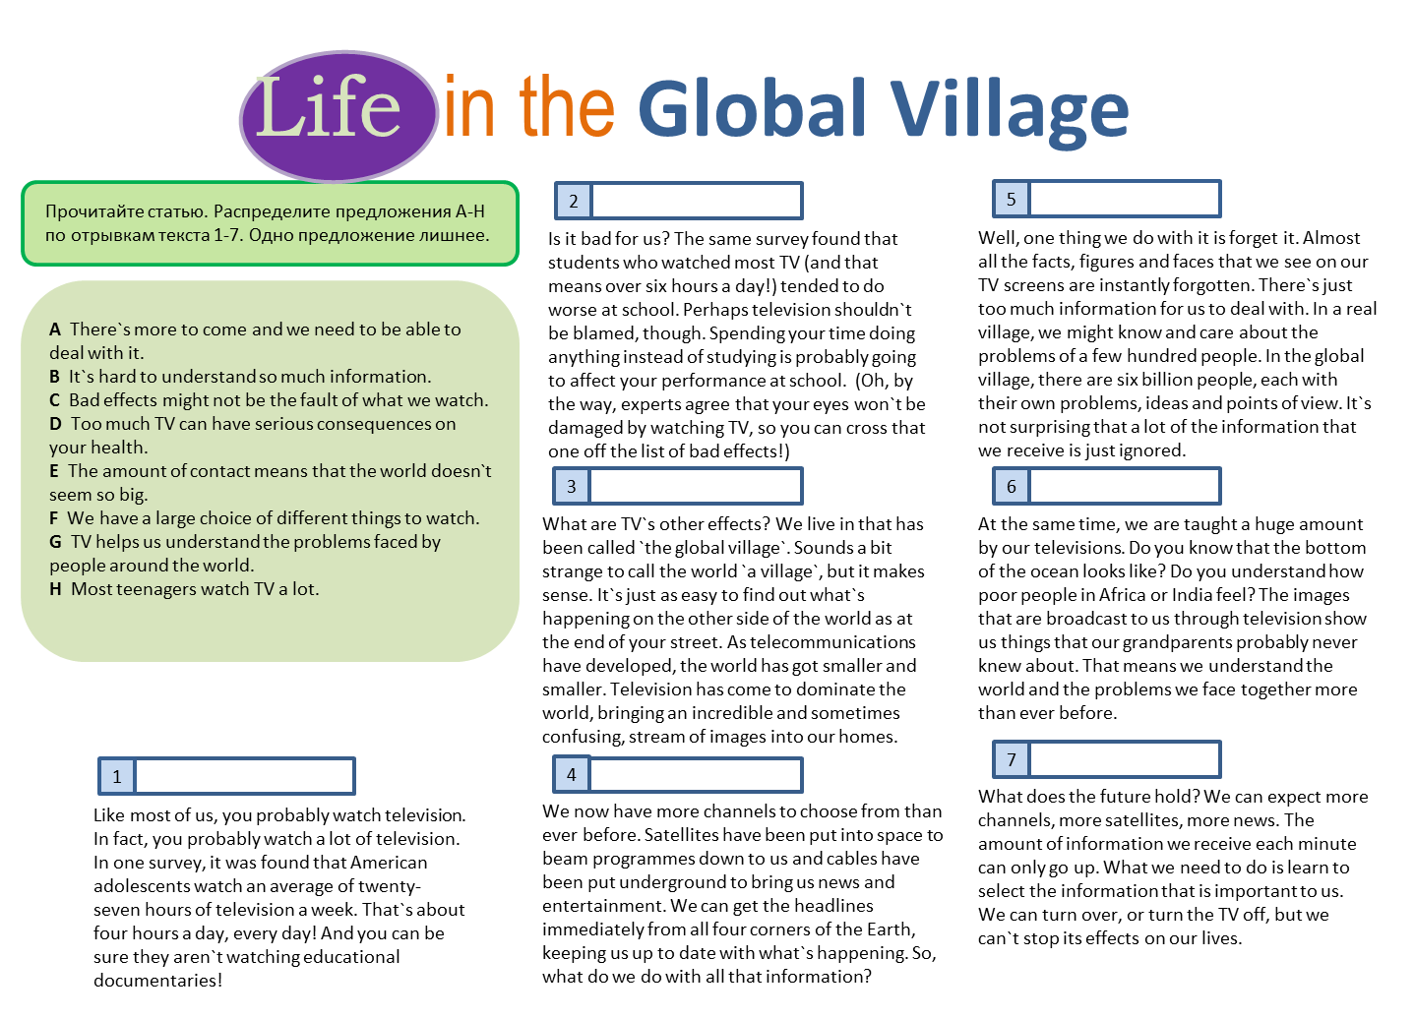

Task 4
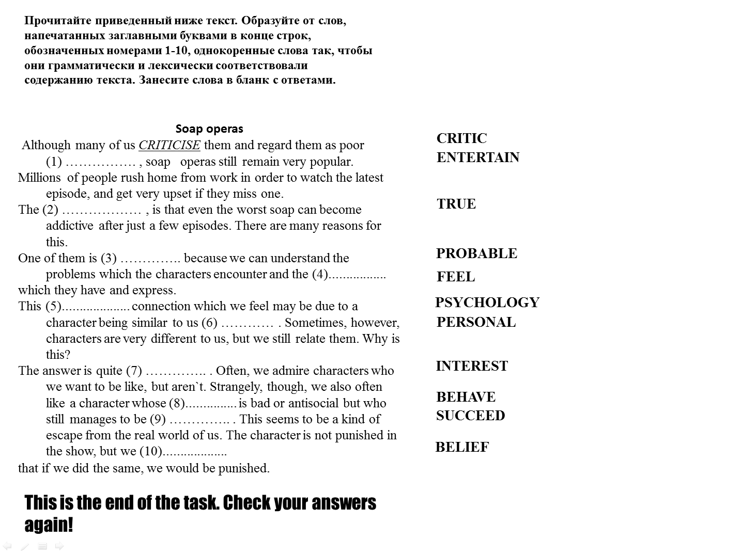
(3)
(4)
(2)
(5)
(6)
(7)
(8)
(9)
(10)
(1)

